* Engineering and Material Over all:

1. The graph should read directly from the engineering/material log, no forms for manual entry, therefor we need to keep that form hidden so we can use it any time if required
2. The legend illistrating the status should be uniformed and consistant with engineering log:
3. Submitted
4. Approved
5. Approved/Comments
6. Rejected
7. Re- Submit
8. Data Date should be upper right hand corner
9. Drop down menue to choose the status in details per building, and it should include all buildings as well

* Shop Drawing and Material Detailed Status:

1. The graph should read directly from the engineering/material log, no forms for manual entry, therefor we need to keep that form hidden so we can use it any time if required
2. The legend illistrating the status should be uniformed and consistant with engineering log with (Delay or on time):
3. Submitted
4. Approved
5. Approved/Comments
6. Rejected
7. Re- Submit
8. Data Date should be upper right hand corner
9. Drop down menue to chose the status in details per Discipline, and it should include all Discipline as well
10. Table of figures should appear beside the graph same as the Engineering statistics report
11. Export to concern is required

* Engineering and Material Statistics:

1. The graph should read directly from the engineering/material log, no forms for manual entry
2. The legend illistrating the status should be Submitted
3. Average Number of revisions not average revisions
4. Average approval Duration
5. Data Date should be upper right hand corner
6. Drop down menue to choose the status in details per Discipline, and it should include all Discipline as well
7. PDF & Email options to be included
8. Export to concern is required

* Engineering and Material Statistics:

1. The graph should read directly from the engineering/material log, no forms for manual entry
2. Data Date should be upper right hand corner
3. Drop down menue to chose the status in details per Discipline, and it should include all Discipline as well
4. PDF & Email options to be included

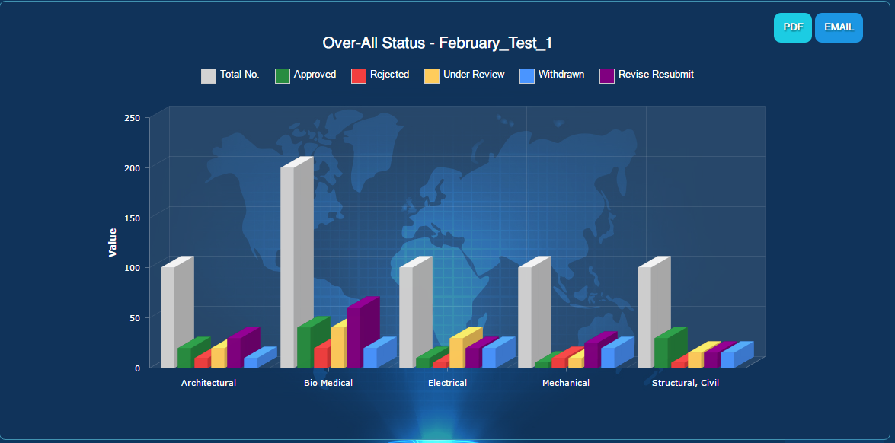

Figures will come automatically from Engineering Log

Data Date

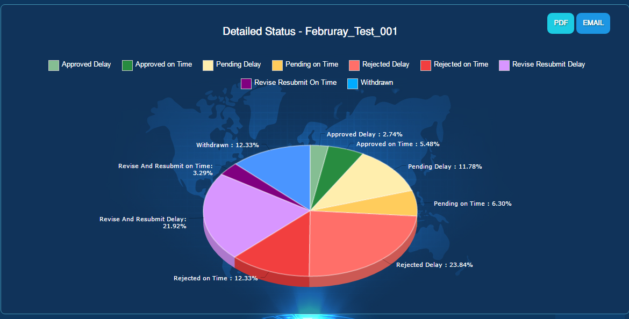

Table of figures

Export to Concerns

Dicsipline

Figures will come automatically from Engineering Log

Data Date

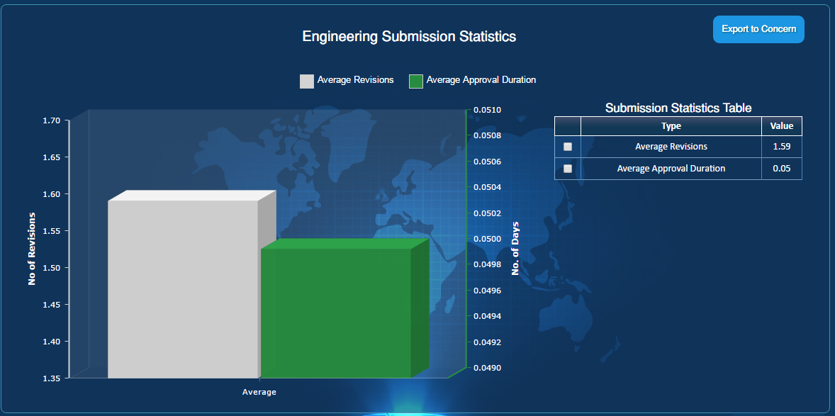

Figures will come automatically from Engineering Log

Email

PDF

Email

PDF

Average # of Revisions

Data Date

Dicsipline

Figures will come automatically from Engineering Log

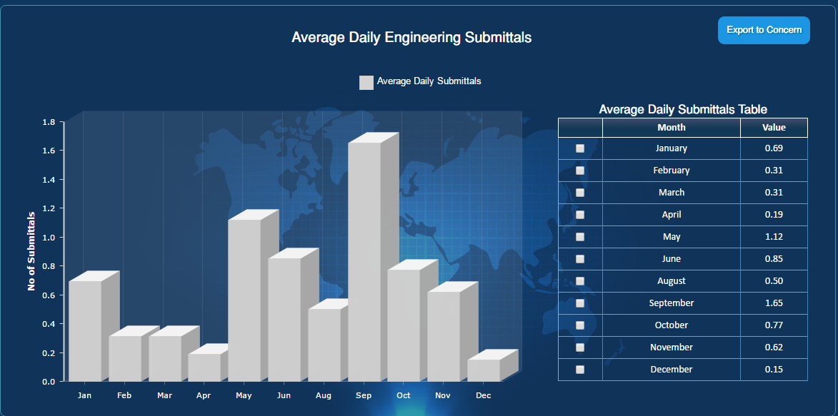

Data Date

Dicsipline